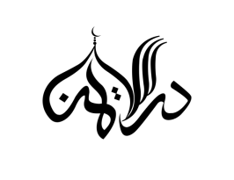
DARUL IMAN ACADEMY 36 Stanislaus, Buffalo, NY 14212 Office: 716-240-9246 Daruliman016@gmail.com
Darulimanbuffalo.org
___________________________________________________________________________________

EXAM AND VACATION DATES FOR SCHOOL YEAR 2022-2023
Start of School Year- May 23rd, 2022

Terms | Dates
First Term Exams | July 25^{th_} August 5th
Second Term Exams | November 14th- 25th
Third Term Exams | March 2nd - 15th

Other Important Dates

Eid-ul-Adha Break | July 8th - 12th
Winter Break | December 17th- January 1st
First Term Start/End | May 23rd - August 5th
Second Term Start/End | August 6th - November 25th
Final Term Start/End | November 26th - March 15th
Report Card and Certificate | March 17th
Next school year starts (Tentative) | May 1st, 2023

Note: Dates are tentative and may change depending on situation. Full Exam week schedule will be given out a week before the exam dates.

